JSON Data Types

🌟 What are JSON Data Types?
# Source: AI Source: Provided by: [Data Path: Persons Table -> ID Column: 1, Name_En Column: Motasem Essam] -> From: [ChatGPT] on [5/31/2026]
JSON Data Types define what kind of values can be stored in JSON.
Every value in JSON must belong to a specific type.

🔑 Common Data Types

📚 1. String
# Source: AI Source: Provided by: [Data Path: Persons Table -> ID Column: 1, Name_En Column: Motasem Essam] -> From: [ChatGPT] on [5/31/2026]
🌟 Definition
Text values written inside double quotes.
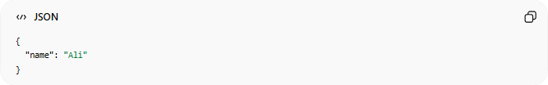
{
"name": "Ali"
}

🔢 2. Number
# Source: AI Source: Provided by: [Data Path: Persons Table -> ID Column: 1, Name_En Column: Motasem Essam] -> From: [ChatGPT] on [5/31/2026]
🌟 Definition
Numeric values (integer or decimal).
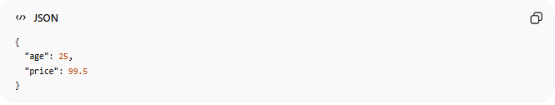
{
"age": 25,
"price": 99.5
}

✅ 3. Boolean
# Source: AI Source: Provided by: [Data Path: Persons Table -> ID Column: 1, Name_En Column: Motasem Essam] -> From: [ChatGPT] on [5/31/2026]
🌟 Definition
True or false values.
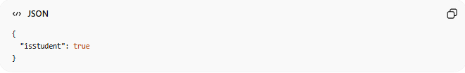
{
"isStudent": true
}

⚫ 4. Null
# Source: AI Source: Provided by: [Data Path: Persons Table -> ID Column: 1, Name_En Column: Motasem Essam] -> From: [ChatGPT] on [5/31/2026]
🌟 Definition
Represents an empty or unknown value.
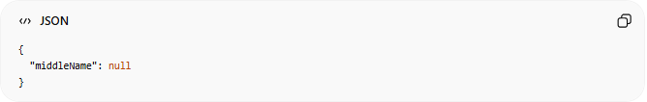
{
"middleName": null
}

🧱 5. Object
# Source: AI Source: Provided by: [Data Path: Persons Table -> ID Column: 1, Name_En Column: Motasem Essam] -> From: [ChatGPT] on [5/31/2026]
🌟 Definition
A structured collection of key-value pairs.
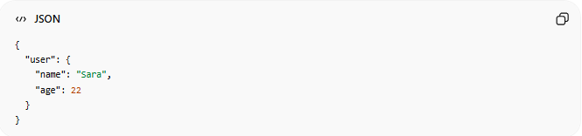
{
"user": {
"name": "Sara",
"age": 22
}
}

📦 6. Array
# Source: AI Source: Provided by: [Data Path: Persons Table -> ID Column: 1, Name_En Column: Motasem Essam] -> From: [ChatGPT] on [5/31/2026]
🌟 Definition
A list of values.
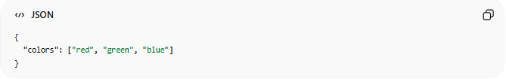
{
"colors": ["red", "green", "blue"]
}

🔄 Mixed Example (All Data Types Together)
# Source: AI Source: Provided by: [Data Path: Persons Table -> ID Column: 1, Name_En Column: Motasem Essam] -> From: [ChatGPT] on [5/31/2026]
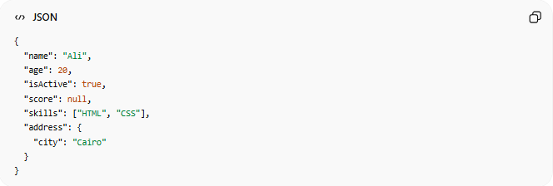
{
"name": "Ali",
"age": 20,
"isActive": true,
"score": null,
"skills": ["HTML", "CSS"],
"address": {
"city": "Cairo"
}
}

⚠️ JSON Data Type Rules
# Source: AI Source: Provided by: [Data Path: Persons Table -> ID Column: 1, Name_En Column: Motasem Essam] -> From: [ChatGPT] on [5/31/2026]
- Strings must use double quotes
- No functions allowed
- No undefined type (not supported)
- Must follow strict format

🧠 Simple Idea
# Source: AI Source: Provided by: [Data Path: Persons Table -> ID Column: 1, Name_En Column: Motasem Essam] -> From: [ChatGPT] on [5/31/2026]
Think of JSON data types like:
📦 Different types of items in a box:
- Text 📄 (String)
- Numbers 🔢
- Yes/No switches 🔘 (Boolean)
- Empty space ⚫ (Null)
- Small boxes 📦 (Objects)
- Lists 📋 (Arrays)

🧭 Summary
# Source: AI Source: Provided by: [Data Path: Persons Table -> ID Column: 1, Name_En Column: Motasem Essam] -> From: [ChatGPT] on [5/31/2026]
JSON supports six main data types: string, number, boolean, null, object, and array, which are used to represent all kinds of structured data in APIs and applications.

